Feasibility Research of Business on Community Micro Regeneration, A UniHub Distributed System Perspective

CHEN Fan¹, MA Yu-Hong², QIAN Li³
¹ Tongji University, China. chenfantj@foxmail.com
² Tongji University, China. mymayuhong@gmail.com
³ Delft University of Technology, Netherland. lqianli@outlook.com

Abstract
From 'extensive way' of economic growth to a more intensive one, China is undergoing a series of social transition which deeply influences the daily life of every one. Taking Shanghai as an example, she is going further on the route of urban fine management. On the other hand, the traditional linear business model has been subverted, community is becoming the new demand side. To respond to the emerging transition mentioned above, this paper attempts to discuss how to facilitate business on the micro regeneration of local community based on a design project collaborated with Uniqlo. The guidance of this project is distributed system thinking, which consists of numerous independent elements, but they are connected with each other in a larger network and work in a resilient way to satisfy residents’ daily demands. Methods used in this research are observation, interview, literature review and case studies. Moreover, with the help of tools of product service system design, the outcome of this research is more credible and improved. At last, the researchers created and tested the concept of “Unihub”, a modular system, in order to explore the feasibility of design-driven business model in a community-based distributed system.

Keywords
Social Transition, Urban Fine Management, Distributed System, Resilience, Economic Model.

1. Introduction
In Jan.11, 2018, the signing ceremony of community planner was held in Siping neighborhood, which indicates another measure had been launched toward urban fine management in Shanghai. The responsibility of community planner is to handle the needs of local residents, mobilize and make them participate into design projects in a bottom-up way, respect the inner order and regulation of communities, renovate different communities and make them update on their own in order to form the domino effect, finally create a cultural space equipped with influence, belongingness and quality of in-site. That is also one of the concrete strategies of micro regeneration in communities. On the other hand, the establishment of community planner rule reflects the intension development requirement of Shanghai government, which regards internal factors as driving force and resource.
Because of the extensive development in earlier years, social resource was wasted in varying degrees, for example, the quantity of vacant property is increasing and they need to be reused in a sustainable way. If we see urban buildings and blocks as containers, Shanghai is getting to need more and more contents that can enrich these undeveloped spaces in a resilient way. Distributed system is a new design thinking derived from computer science field and provide us with another perspective of resolution, it promotes that the central function should be transferred to lower level, which can relieve the central pressure and make good advantage of local activeness.
At the same time, traditional business model, invention—product—industrial design—marketing—client, is getting to be subverted, community and neighborhood are becoming new demand sides. The distance between invention and client is diminishing.

2. Literature Review
Open Your Space: Design Intervention for Urban Resilience mainly discusses the public space creation in a perspective of resilient city. Besides the introduction of design activism theory and some business projects, the second chapter mainly analyzes several design-driven initiatives emerged in China, all of them were practiced by students and in different kinds of artistic ways. According to the author, these community micro regeneration projects were based on class and they introduced the whole process of how these design projects invented. However, the sustainability and the interconnection between these projects are weak, which means these projects have not transferred the community into a self-updated system, and currently they seem like diffused decorated installations rather than a growing system.
Also, Ezio Manzini introduced some community micro regeneration projects practiced by students in Politecnico di Milano in Design, When Everybody Designs. Students were divided into several groups and developed their own projects under the direction of a unified theme. Although the connection was established between different projects, they still lack for capital support and sustainability in the future.
Based on the condition mentioned above, if there is a clear theme connects all of the students’ works, and if sufficient social capital can support these ideas, a more influential community-based micro regeneration system will be established and continually update the community.

3. Methodology
In terms of the phenomena mentioned in last part, this research decides to choose Siping neighborhood as research object, for it is the original testing field of community planners and more experience has been accumulated. Observation and interview are main methods to collect research materials, which include current condition description of infrastructure, local residents’ attitude and suggestions toward service system, etc., all of them can help to correct the direction of upcoming solution. On the other hand, pointed literature review and case study provide theoretical basis with researchers. Besides, this research makes advantage of product system service design tools, for instance, personas, customer journey map, story board, service blueprints, etc.

4. Discussion
Based on research questions and distributed system thinking, this paper attempts to reflect to current condition and create a new business service model, Unihub, combined with Uniqlo, which consists of substantial installations and online service system. As consultant and sponsor, Uniqlo offers design prototypes and funding to this research, of which the product materials are used as research foundation. Unihubs are diffused in the city and interwoven with each other, of which the effect likes acupuncture and will have a systematic influence toward the whole organism, Siping residents, our target customer.

4.1. Concept Map of Unihub
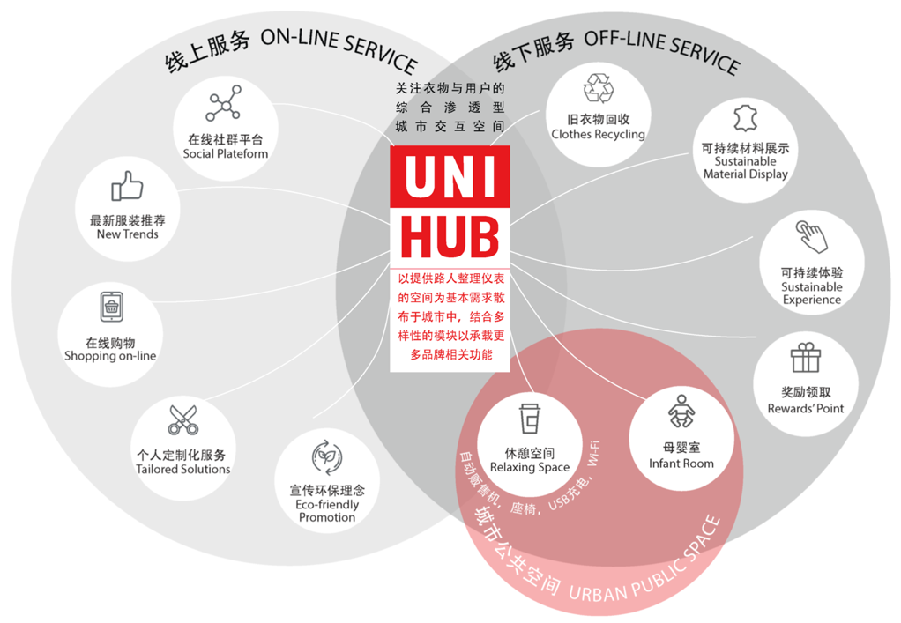
Figure. 1. Concept Map of Unihub
As is shown in the concept map (Figure.1.), Unihub is a module system that extends stores’ functions to communities in order to reach more effective advertising and stimulate the vitality of communities. It will undertake three main functions in the city, online service, offline service and urban public infrastructure.
Online service includes five aspects: 1. Social Platform is an online virtual space in which local residents can interact and share experience with each other; 2. New trends recommendation is an advertising part that informs new products and trends of Uniqlo; 3. Online shopping extends the shopping function of Uniqlo physical stores to communities, which is more convenient for customers and is also one of the new retail modes; 4. People can use Tailored Solution to contact with Uniqlo staff to make customized change of clothes; 5. Eco-friendly Promotion helps to advocate recycling idea of Uniqlo, this is also an extensive function from physical stores toward communities.
Then, offline service of Unihub covers four sides: 1. Local residents can choose the closest Unihub to drop their old clothes into the storage box and Uniqlo staff will pick them up periodically; 2. Inside the Unihub, sustainable fabrics from old clothes will be exhibited; 3. To encourage residents and neighbors to continue to pay attention to sustainability career, souvenirs made up of old fabrics will be sent to users as rewards; 4. As a virtual fitting room, Unihubs can help pedestrians to take care of their appearance.
Last but not least, as urban public infrastructure, Unihubs will act as infant rooms to provide convenience with parents who need to breed babies. On the other hand, as a relaxing space, Unihubs will also offer USB chargers and free Wi-Fi to pedestrians.

4.2. Quality of Unihub
The physical characters and potential properties describe the developing possibilities of Unihub. The fundamental character is modularization, which is the substantial foundation of distributed system toward community regeneration; based on this, growth and extensibility are derived, they are driving force of community regeneration and social reforming.
4.2.1. Prefabricated Modularization
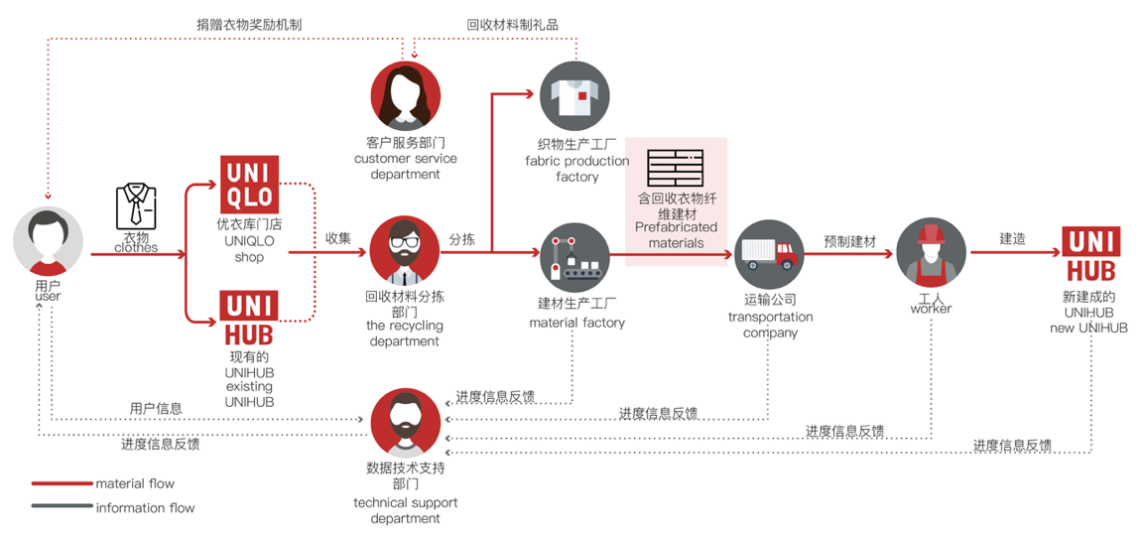
Figure. 2. Old Clothes Recycling System Map
The foundation of modularized establishment is recycled old clothes, which responses to the charitable goal of Uniqlo. After users dropped their useless clothes, the recycling department staff will select and divide these clothes into two parts, some of them are delivered to building material factory, there old clothes will be transferred to anti-crack fiber and combined with concrete, then reinforcement building material will be produced and sent to make new Unihubs; the others are delivered to fabric production factory and used for making rewards to users. All of the processes will be recorded by technical department and the information can be interacted with users (Figure.2.).
Made up of prefabricated modularization materials, four standard modules are created: Uniqlo sales terminal, old clothes recycling, parents nursing closet and public relaxing infrastructure (Figure.3. a.— d.). Each of them is generally 1.5m*1.5m*2m size, which makes them combine with each other conveniently in order to transfer into different functional systems, also satisfies multiple needs of local people. The prefabricated modules are delivered to demand sides directly from factories, which improves the efficiency of assembling and reduces the influence toward environment under the guidance of sustainable thinking.
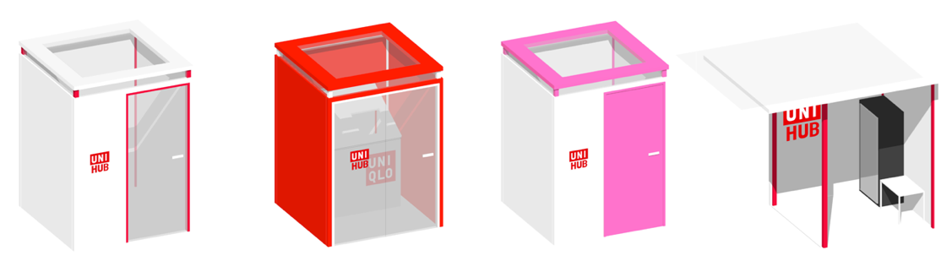
a. b. c. d.
Figure. 3. four standard modules
As is shown in the figure, module a is the core module of Unihub, it mainly undertakes online service. Then, module b can provide local residents with old clothes recycling service, in which a storage box is installed. In module b, user can search for the terminal and the current condition of the good, which reflects the sustainability. Next, module c is created to care for special groups, especially nursing mothers and their babies, for the present infrastructure is still weak in this field. At last, module d can offer not only vending machine service, but also relaxing public infrastructure.
4.2.2. Growth
Unihubs are the results of public will and contribution. After selection, old clothes are transported to factories and processed into anti-crack fiber, then produced to be prefabricated materials. In this process, users can decide which area they are willing to donate and organize a community with local residents based on Unihubs. On the other hand, rest of the old clothes can be made as materials of souvenirs and sent to users who reach the standard. Actually, the old clothes recycling system is the foundation of Unihubs’ establishment, vice versa. Moreover, the recycling system will get stronger because of the popularity of Unihubs, which is also the foundation of distributed system and community-based micro regeneration.
4.2.3. Extensibility
Unihubs that are established by geological factors will probably be touch points of subjective communities. Combined with activities hold by Uniqlo, local residents will focus more on the development of the city and which can be transferred to a social reforming force of public participation.

5. Conclusion
With the help of product system service design tools, Unihub prototype has been tested by Siping neighbors and Uniqlo staff, the results indicate that both neighbors and business are willing to make Unihub to be true and spread it around.
As a combination of environmental design and product system service design, Unihub is not only a functional urban public infrastructure, but also a touch point which will engage local residents into the self-renewal system toward community, then communities will be regenerated by these bottom-up approaches. Based on the experience of creating Unihub, researchers will continually promote this concept, distributed system in urban micro regeneration, to related projects and make the whole city to be a self-updated system.

References
Ming-Qin, N., Ming-Jie, Z. (2017). Open Your Space: Design Intervention for Urban Resilience (pp. 178–200). Shanghai: Tongji University Press.

Ezio, M. (2016). Design, When Everybody Designs (pp. 162-180). Beijing: Publishing House
of Electronics Industry.

Pei, Z. (2018). Community Planner Regulation Has Been Operated in Full Scale in Yangpu District. Retrieved from http://city.eastday.com/gk/20180116/u1a13590203.html

Yong-qi, L. (2018). NICE 2035: An Experiment of Design Driven Community-supported Social Innovation. Art & Design, 301, 34-39. doi: 10.16272/j.cnki.cn11-1392/j.2018.05.007

